Persistent Depressive Disorder

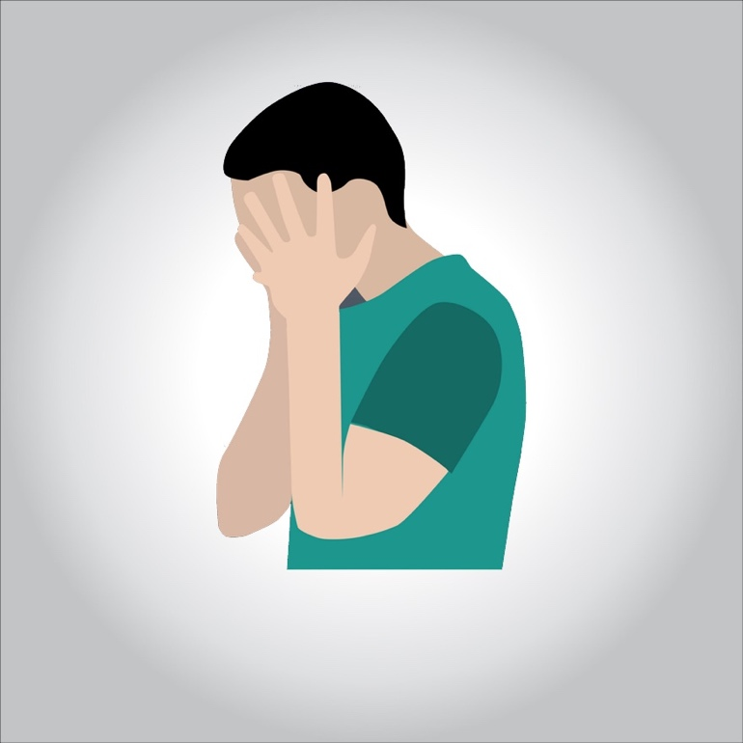

**Persistent depressive disorder (PDD) is a form of chronic depression. It’s a relatively new diagnosis that combines the two earlier diagnoses dysthymia and chronic major depressive disorder. Like other types of depression, PDD causes continuous feelings of deep sadness and hopelessness. These feelings can affect your mood and behavior as well as physical functions, including appetite and sleep. As a result, people with the disorder often lose interest in doing activities they once enjoyed and have difficulty finishing daily tasks.**

**These symptoms are seen in all forms of depression. In PDD, however, the symptoms are less severe and longer lasting. They can persist for years and may interfere with school, work, and personal relationships. The chronic nature of PDD can also make it more challenging to cope with the symptoms. However, a combination of medication and talk therapy can be effective in treating PDD.**

**Symptoms of Persistent Depressive Disorder**

**The symptoms of PDD are similar to those of depression. However, the key difference is that PDD is chronic, with symptoms occurring on most days for at least two years. These symptoms include:**

* **persistent feelings of sadness and hopelessness**
* **sleep problems**
* **low energy**
* **a change in appetite**
* **difficulty concentrating**
* **indecisiveness**
* **a lack of interest in daily activities**
* **decreased productivity**
* **poor self-esteem**
* **a negative attitude**
* **avoidance of social activities**

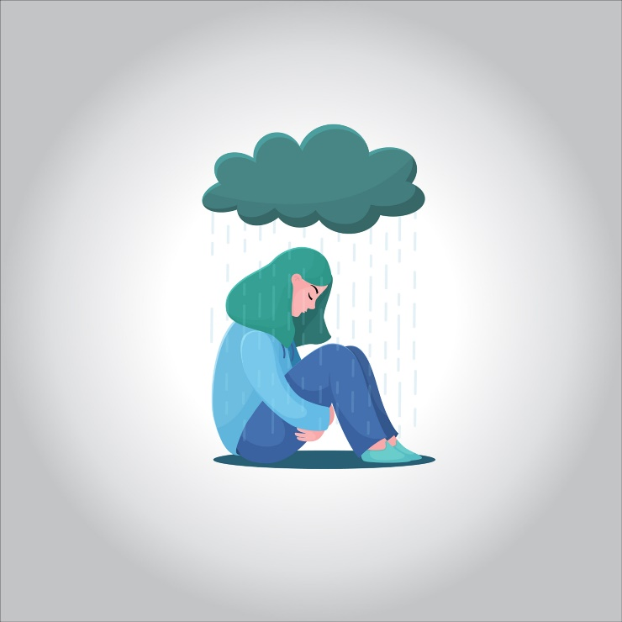

**The symptoms of PDD often begin to appear during childhood or adolescence. Children and teens with PDD may appear to be irritable, moody, or pessimistic over an extended period. They may also display behavior problems, poor performance at school, and difficulty interacting with other children in social situations. Their symptoms may come and go over several years, and the severity of them may vary over time.**

**Causes of Persistent Depressive Disorder**

**The cause of PDD isn’t known. Certain factors may contribute to the development of the condition. These include:**

* **a chemical imbalance in the brain**
* **a family history of the condition**
* **a history of other mental health conditions, such as anxiety or bipolar disorder**
* **stressful or traumatic life events, such as the loss of a loved one or financial problems**
* **chronic physical illness, such as heart disease or diabetes**
* **physical brain trauma, such as a concussion**

**Diagnosing Persistent Depressive Disorder**

**To make an accurate diagnosis, your doctor will first perform a physical examination. Your doctor will also perform blood tests or other laboratory tests to rule out possible medical conditions that may be causing your symptoms. If there’s no physical explanation for your symptoms, then your doctor may begin to suspect that you have a mental health condition.**

**Your doctor will ask you certain questions to assess your current mental and emotional state. It’s important to be honest with your doctor about your symptoms. Your responses will help them determine whether you have PDD or another type of mental illness.**

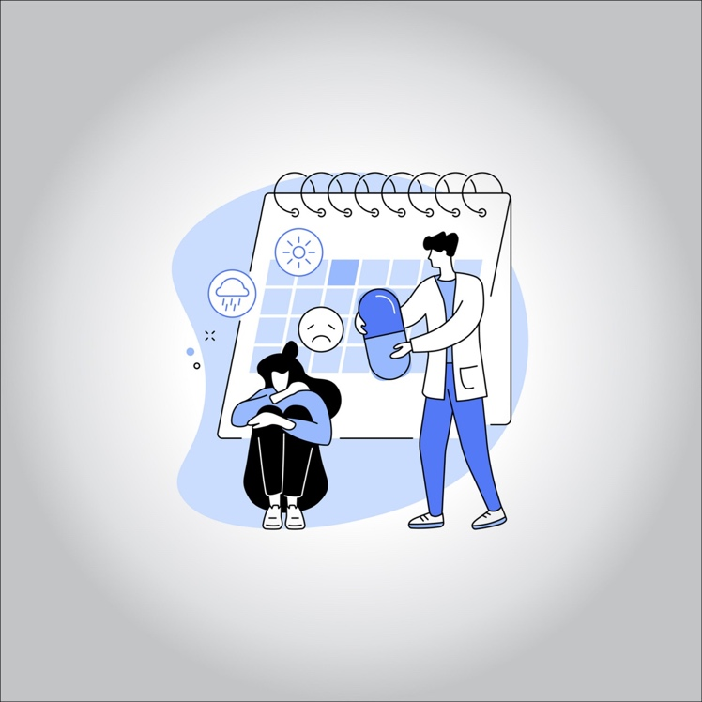

**Many doctors use the symptoms listed in the Diagnostic and Statistical Manual of Mental Disorders (DSM-5) to diagnose PDD. This manual is published by the American Psychiatric Association. The PDD symptoms listed in the DSM-5 include:**

* **a depressed mood almost every day for most of the day**
* **having a poor appetite or overeating**
* **difficulty falling asleep or staying asleep**
* **low energy or fatigue**
* **low self-esteem**
* **poor concentration or difficulty making decisions**
* **feelings of hopelessness**

**For adults to be diagnosed with the disorder, they must experience a depressed mood most of the day, nearly every day, for two or more years.**

**For children or teens to be diagnosed with the disorder, they must experience a depressed mood or irritability most of the day, nearly every day, for at least one year.**

**Treating Persistent Depressive Disorder**

**Treatment for PDD consists of medication and talk therapy. Medication is believed to be a more effective form of treatment than talk therapy when used alone. However, a combination of medication and talk therapy is often the best course of treatment.**

**Medications**

**PDD can be treated with various types of antidepressants**

**You may need to try different medications and dosages to find an effective solution for you. This requires patience, as many medications take several weeks to take full effect.**

**Talk to your doctor if you continue to have concerns about your medication. Your doctor may suggest making a change in dosage or medication. Never stop taking your medication as directed without speaking to your doctor first. Stopping treatment suddenly or missing several doses may cause withdrawal-like symptoms and make depressive symptoms worse.**

**Therapy**

**Talk therapy is a beneficial treatment option for many people with PDD. Seeing a therapist can help you learn how to:**

* **express your thoughts and feelings in a healthy way**
* **cope with your emotions**
* **adjust to a life challenge or crisis**
* **identify thoughts, behaviors, and emotions that trigger or aggravate symptoms**
* **replace negative beliefs with positive ones**
* **regain a sense of satisfaction and control in your life**
* **set realistic goals for yourself**

**Talk therapy can be done individually or in a group. Support groups are ideal for those who wish to share their feelings with others who are experiencing similar problems.**

**Lifestyle Changes**

**PDD is a long-lasting condition, so it’s important to participate actively in your treatment plan. Making certain lifestyle adjustments can complement medical treatments and help ease symptoms. These remedies include:**

* **exercising at least three times per week**
* **eating a diet that largely consists of natural foods, such as fruits and vegetables**
* **avoiding drugs and alcohol**
* **seeing an acupuncturist**
* **taking certain supplements, including St. John’s wort and fish oil**
* **practicing yoga, tai chi, or meditation**
* **writing in a journal**